**Deleting Full Back up in Prod DB1 Server**

**NOTE: Before deleting the full backup kindly take a snapshot for concerned disk in GCP console.**

**Step -1:** Login to TVS-APP-PRODB1 server and Navigate to E-Drive.

**Step -2:** IN which navigate to Full backup folder.

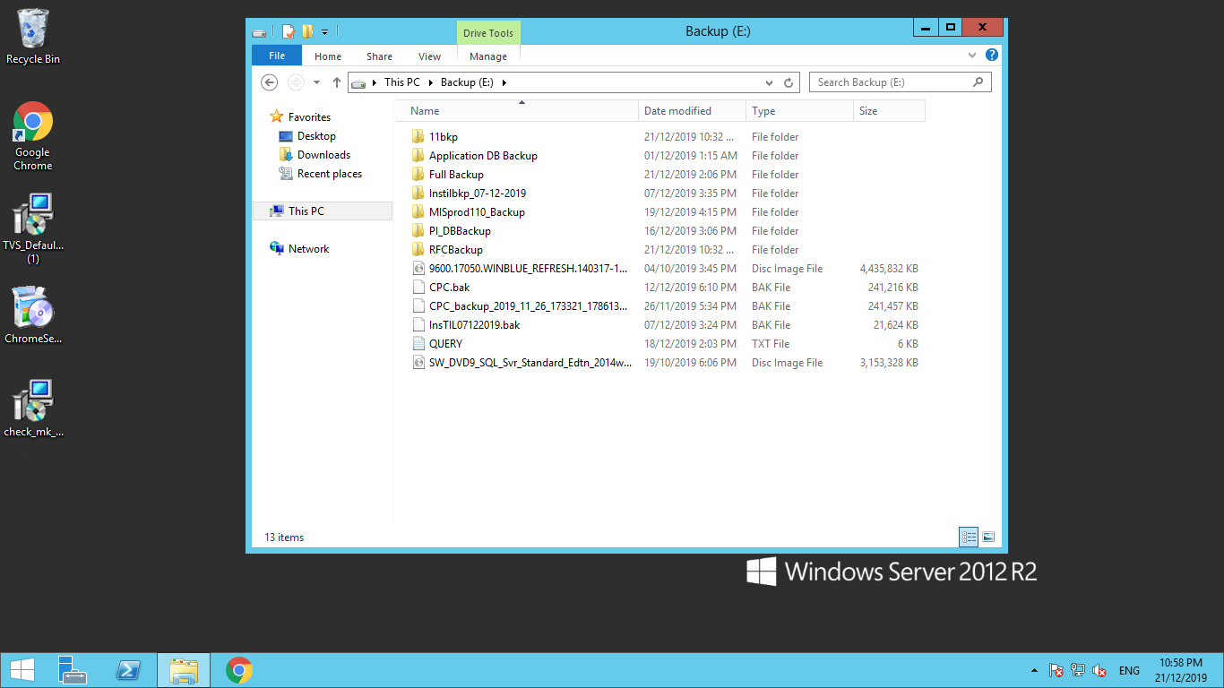

**Step -3:** In which MIS Prod DB backup is available, Kindly click on that.

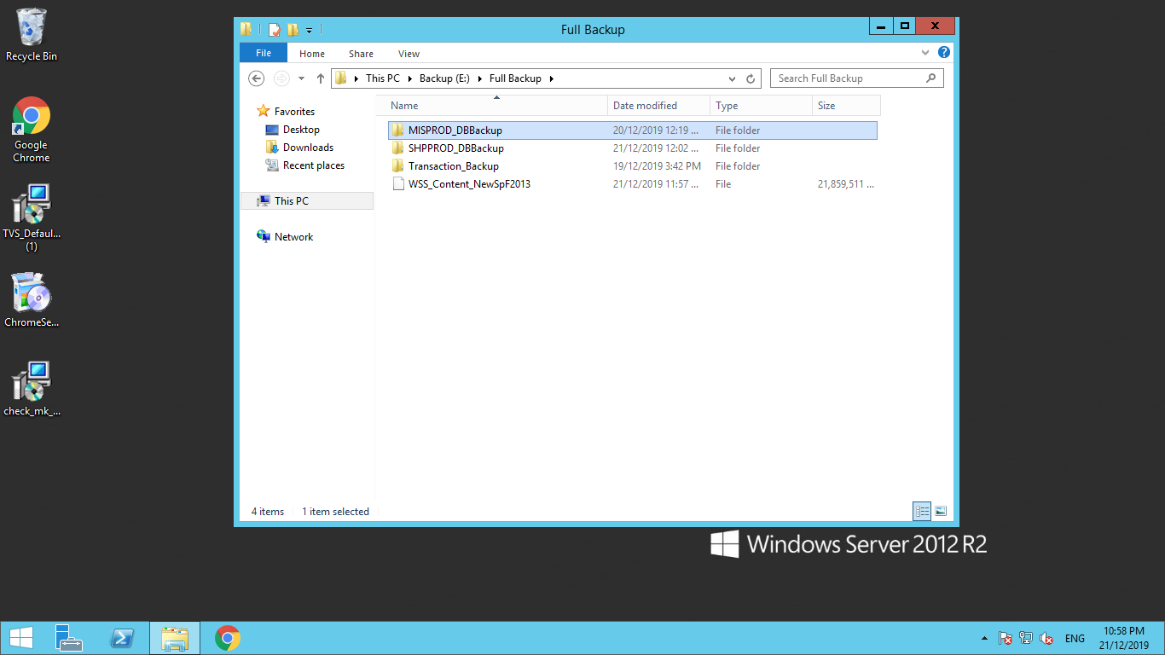

**Step -4:** Delete the available backup files **except** the **db_MCollect Folder**

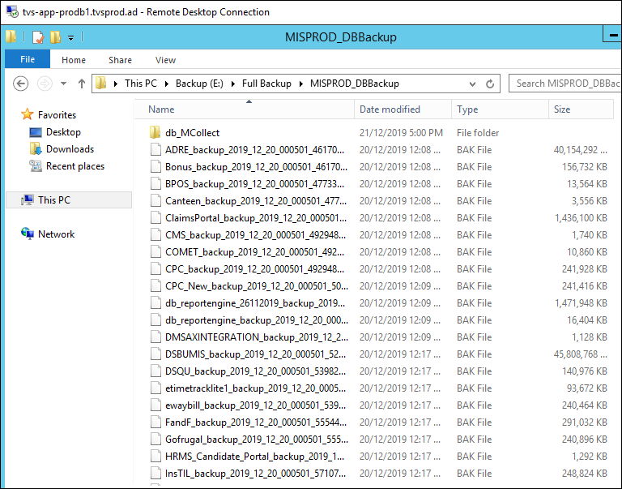

**Step -5:**Once the backup files in above folder is deleted navigate to **SHPPROD_DBBackup**

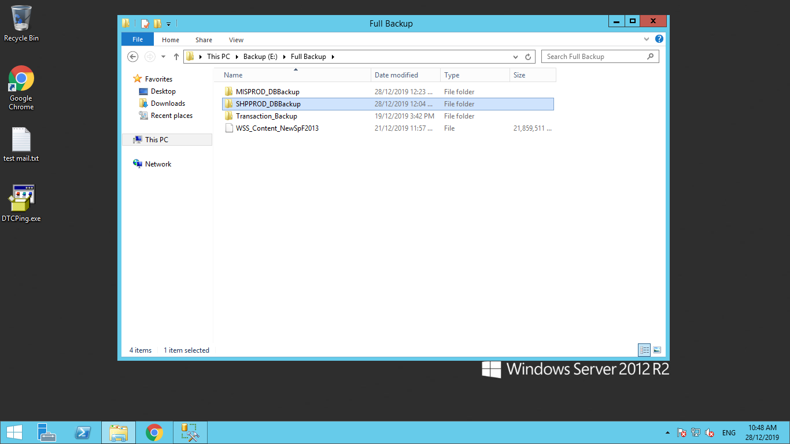

**Step -6**: Kindly click on the folder and delete the available files, **Note: Before deleting kingly take a snapshot for the drive in GCP Console.**

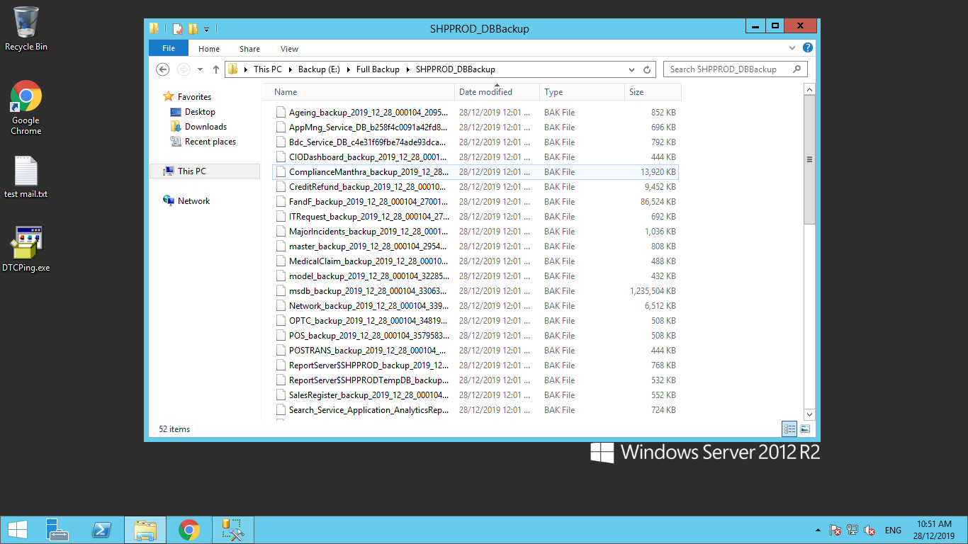

**Deleting Full Back up in AXDB1 Server**

**NOTE: Before deleting the full backup kindly take a snapshot for concerned disk in GCP console.**

**Step -1:** Login to TVS-APP-AXDB1 server and Navigate to J-Drive.

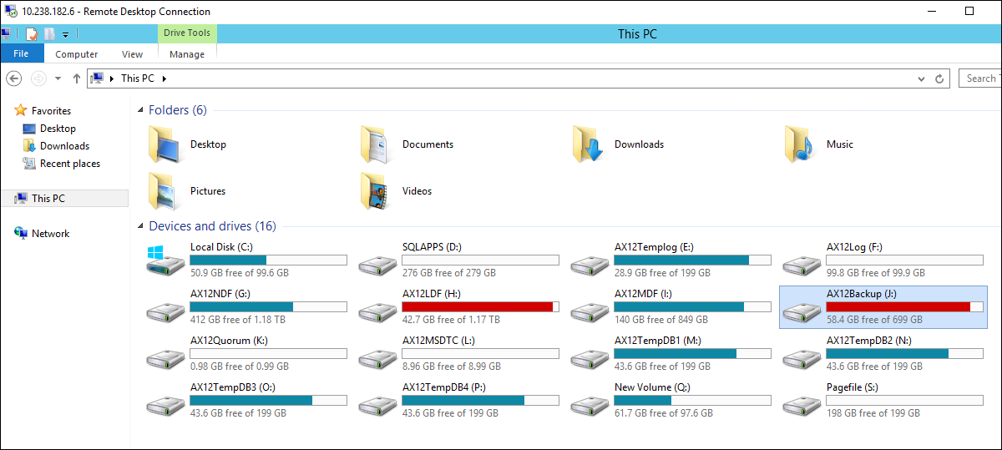

**Step -2:** In which navigate to AX12_DBBackup folder.

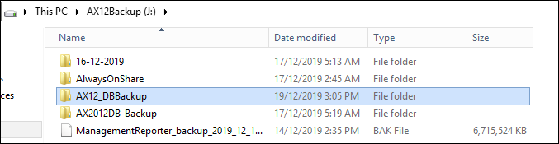

**Step -3:** In which click on Full Backup

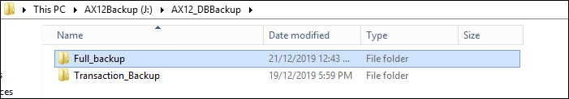

**Step -4:** Delete the available backup files.

